Ocean Life Post-Assessment

Name: ________________________ Date: ________________

1. What is an ocean?
a. small body of water b. large body of water c. a river

2. What do fish use to breathe?
a. blowhole b. nose c. gills

3. Which of these do not belong to a fish?
a. shells b. scales c. fins

4. How many arms does a starfish have?
a. four (4) b. five (5) c. six (6)

5. What kind of creature is this?
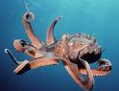
a. octopus
b. lobster
c. eel

6. What kind of creature is this?
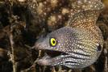
a. squid
b. eel
c. jellyfish

7. How do sharks swim?
a. float b. move their bodies side to side c. hold onto other fish

8. Where do lobsters live?
a. Near the surface b. On the beach c. At the bottom of the ocean

9. Jellyfish don’t have ____________.
a. brains b. bones c. both a and b

10. Sea anemones sting all fish except the _____________.
a. clownfish b. starfish c. jellyfish

11. Sea urchins often live in the ________________.
a. coral reefs b. tidal pools c. both a and b

12. What do dolphins use to breathe?
a. gills b. blowhole c. nose

13. Why is the ocean important to sea creatures? ____________________

_________________________________________________________

14. Why is the ocean important to humans? _________________________

_________________________________________________________

15. Use the word bank to label the layers of the ocean below:


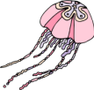

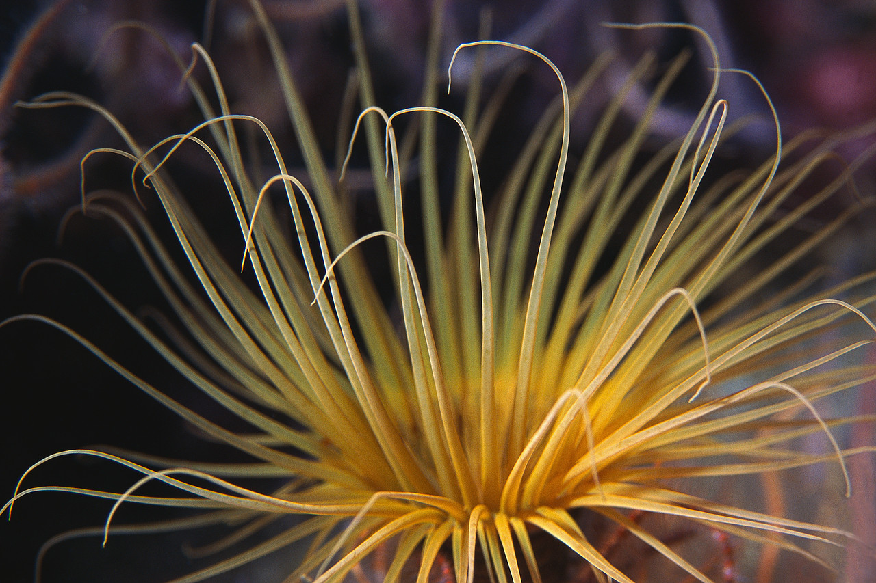
Word Bank for Ocean Layers

tidal pool
ocean floor
open sea
abyss
surface

